PRACTICAL ASSESSMENT TASK 2: SUBTASK 2: WORKSHEET 2
C++ program for Morse code translation
Student’s surname and First name/s | Mkhambi Lesego Elias
Student’s ID number | 0408066049086
Class group | IT & ROBOTICS L3
Assessment date
GitHub repo link.
https://github.com/LOKHUNJA/pat2-subtask1.git

GitHub commit screenshot.
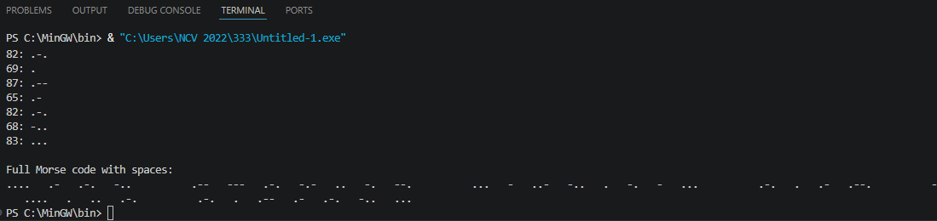

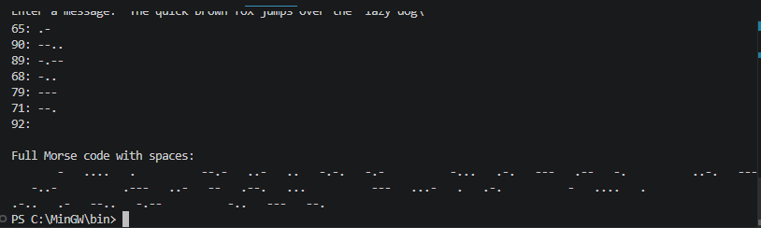
C++ Program source code
#0408066049086
#include <iostream>
#include <string>
#include <cctype>

using namespace std;

// Function to return Morse code for each letter
string getMorseCode(char letter)
{
switch (toupper(letter))
{
case 'A': return ".-";
case 'B': return "-...";
case 'C': return "-.-.";
case 'D': return "-..";
case 'E': return ".";
case 'F': return "..-.";
case 'G': return "--.";
case 'H': return "....";
case 'I': return "..";
case 'J': return ".---";
case 'K': return "-.-";
case 'L': return ".-..";
case 'M': return "--";
case 'N': return "-.";
case 'O': return "---";
case 'P': return ".--.";
case 'Q': return "--.-";
case 'R': return ".-.";
case 'S': return "...";
case 'T': return "-";
case 'U': return "..-";
case 'V': return "...-";
case 'W': return ".--";
case 'X': return "-..-";
case 'Y': return "-.--";
case 'Z': return "--..";
default: return "";
}
}

int main()
{
string message;
string fullMorse = "";

// Ask user for input
cout << "Enter a short message: ";
getline(cin, message);

cout << "\nMorse Code Translation:\n";

// Loop through each character
for (int i = 0; i < message.length(); i++)
{
char ch = message[i];

// Check for spaces between words
if (ch == ' ')
{
fullMorse += " "; // 7 spaces between words
}
else
{
string morse = getMorseCode(ch);

// Display letter and Morse code
cout << toupper(ch) << ": " << morse << endl;

// Add to full Morse message
fullMorse += morse + " "; // 3 spaces between letters
}
}

// Display full Morse code message
cout << "\nFull Morse code with spaces:\n";
cout << fullMorse << endl;

return 0;

